
Assessment Cover Page
Student Full Name | Luiz Henrique Saraiva
Student Number | 2026367
Module Title | Professional Skills and Ethics
Assessment Title | Professional Skills and Ethics CA 1
Lecturer/Supervisor | Martha Gilheaney
Assessment Due Date | 4th October
Date of Submission | 02/10/2026

TO DO: review all text and make sure that it is complete according to the question.
Complete this week's calendar and update on this doc.
Finish the personal mission statement.
Fill the AI doc.

Weekly Calendar

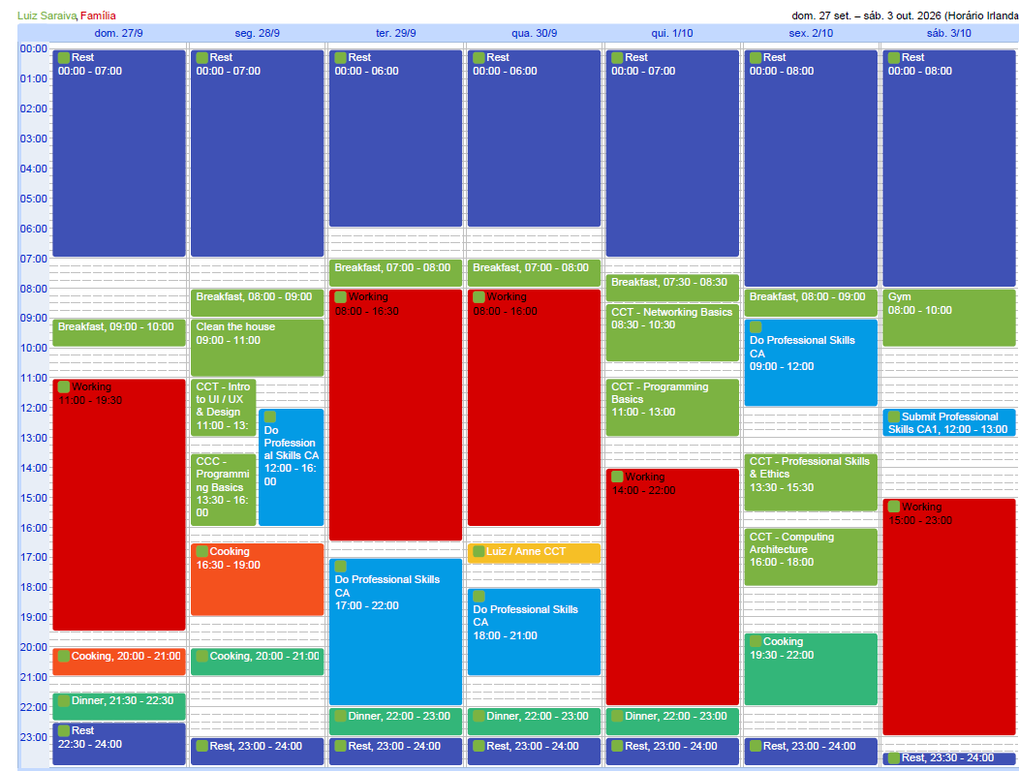

Personal SMART goal

INITIAL GOAL: Go to the gym regularly and improve my health and fitness.

S(SPECIFIC): I want to go to the gym at least four times a week and build a consistent workout routine by December 2026. My main challenge is organizing my weekly routine to have enough free time for the gym. I want to achieve this goal to improve my health, fitness, and energy.

M(MENSURABLE): I can track my progress using my workout app, wich shows how many times I go to the gym each week.

A(ACHIEVABLE): I already go to the gym once or twice a week, so going four times a week is achievable. I need to organize my weekly routine better and make more time for exercise. I am motivated to do this because I want to feel healthier and have more energy, and I believe the effort is worth the benefits.

R(RELEVANT): I used to go to the gym when I lived in Brazil, but since I came to Ireland, it has been difficult to organize my routine and maintain a healthy lifestyle. I often feel tired, low on energy, and have body aches. I believe that getting back to a regular workout routine will help me feel better and improve my lifestyle.

T(TIME-BOUND): I have already started going to the gym, but it has been difficult to go consistently every week. Currently, I go about once or twice a week. My goal is to increase this to at least four times a week by December 2026.

SMART GOAL: My goal is to go to the gym at least four times a week by December 2026 and maintain this routine. I need to organize my routine better to have enough free time for the gym. I will use my workout app to track my progress and help me build a healthier lifestyle.

Professional SMART goal

INITIAL GOAL: Get a job as a Software Enginner in Ireland.

S(SPECIFIC): I want to get a job as a Software Enginner in Ireland by September 2027, preferably in the banking or financial services industry. I already have experience in this field, but I need to continue improving my technical and English skill to achieve this goal.

M(MENSURABLE): I can mensure my progress by applying for at least 5 Software Enginner position per week and tracking the number of interviews I get. I will know I have achieved my goal when I receive and accept a job offer.

A(ACHIEVABLE): I already have experience in IT and Software development. I am currently studying Computer Science and creating an extra study plan to improve my skills and be better prepared for Software Enginner position in Ireland.

R(RELEVANT): This goal is important to me because I want to develop my international career and return to working in Software development, wich was my field in Brazil. This career will also help me have a more comfortable and stable life.

TIME-BOUND: My deadline is September 2027. During this period, I will focus on my Computer Science studies, follow my extra study plan, improve my English, and prepare myself for the job market.

SMART GOAL: My goal is to get a job as a Software Engineer in Ireland by September 2027, preferably in the banking or financial services industry. To achieve this goal, I will continue my Computer Science studies, follow my extra study plan, improve my English and apply for at least 5 Software Engineer positions per month. This goal is important to me because I want to develop my international career, return to working in software development and build a more comfortable and stable life in Ireland.

Core Values
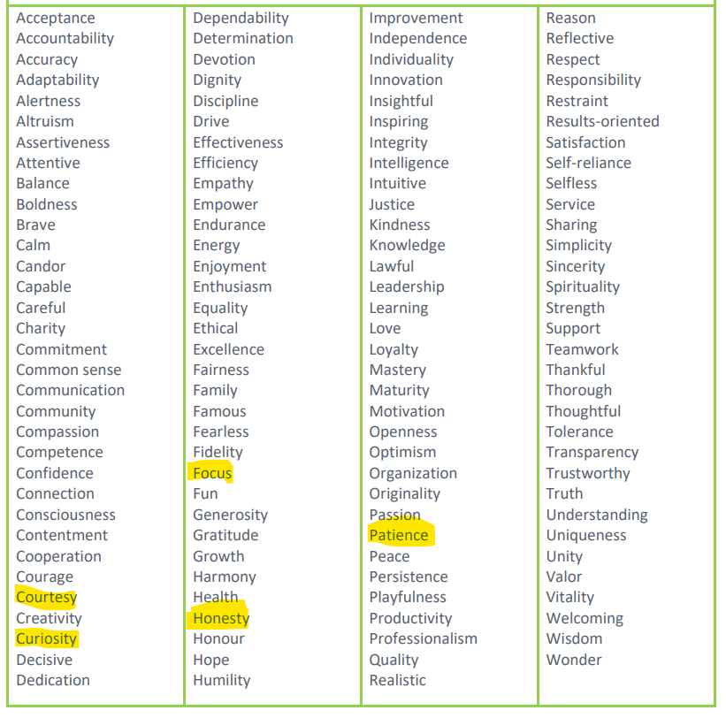

Personal Mission Statement

My mission is to keep learning and growing as a person and professional. I want to be honest and sincere with myself and other people, because these are important values for me. I am curious and I enjoy solving problems and finding solutions. I want to use this in my career and do something that I enjoy and where I can see value in my work.

I know that achieving my goals takes time and effort, so I want to keep studying and improving my knowledge. At the same time, I don't want my life to be only about work and study. Having time for myself, my family and taking care of myself is also important. I want to have a comfortable and peaceful life, with the freedom to make my own decisions without pressure.

In the future, I want to look back and be happy with the decisions I made, not only because of my career, but also because I enjoyed my life, helped other people when I could and stayed true to my values.
Procrastination style

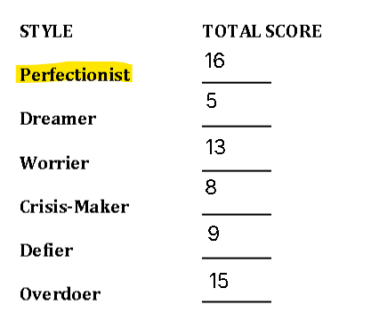

Declaration of AI Use — AI Fluency Framework
This assessment applies to CCT College Dublin's AI Fluency Framework — four interconnected competencies that ensure your engagement with AI is effective, efficient, ethical and safe: Delegation, Description, Discernment and Diligence. Full detail on what AI use is permitted for this assessment, and the evidence you must provide, is set out in your Assessment Brief.
Delegation  Setting goals and deciding whether, when and how to engage with AI. | Description  Effectively describing goals to prompt useful AI behaviours and outputs.
Discernment  Accurately assessing the usefulness of AI outputs and behaviours. | Diligence  Taking responsibility for what we do with AI and how we do it.
Adapted from the AI Fluency Framework (Dakan, Feller, Anthropic, 2025).

Filling Out the Cover Sheet
- Fill out the top section of the cover page with all the required information.
- Complete the Student Response column of the AI Declaration table in the appendix of this cover, evidencing your Delegation, Description, Discernment and Diligence.

Appendix: AI Declaration using the AI Fluency Framework
Copy and paste the AI Declaration table from your Assessment Brief HERE. Then follow your lecturers expectations to complete the ‘student response’ section.
AI competence | Reflective prompts (to students) | Lecturer expectations | Student response
Delegation  Deciding whether & when to use AI | Identify the specific tasks in this assessment where you chose to use AI, and explain your reasoning. Where did AI add value? Where did you decide not to use it, and why? | [Lecturer expectations - see assessment brief template] | [Student response - follow lecturer instructions in the expectations column]
Description  How you prompted the AI | Include the exact prompts you used in your appendix (recorded on the AI Tools declaration). Reflect on how you communicated your goals to the AI — did you need to iterate or refine your prompts to get useful output? | [Lecturer expectations - see assessment brief template] | [Student response - follow lecturer instructions in the expectations column]
Discernment  Evaluating what the AI produced | In your reflection (~100 words), critically evaluate the AI output: what did you accept, modify, or reject — and why? Assess accuracy, relevance, and quality. You are responsible for verifying all AI-generated content before submitting. | [Lecturer expectations - see assessment brief template] | [Student response]
Diligence  Responsibility for your AI use | Declare all AI tools used and cite them here. Briefly outline (~100 words) how you considered data protection, copyright, and ethical responsibilities when choosing what to input into any AI system. Unauthorised use is subject to CCT disciplinary procedures. | [Lecturer expectations - see assessment brief template] | [Student response]

